# Day 1- Postgres Script Demo

1. 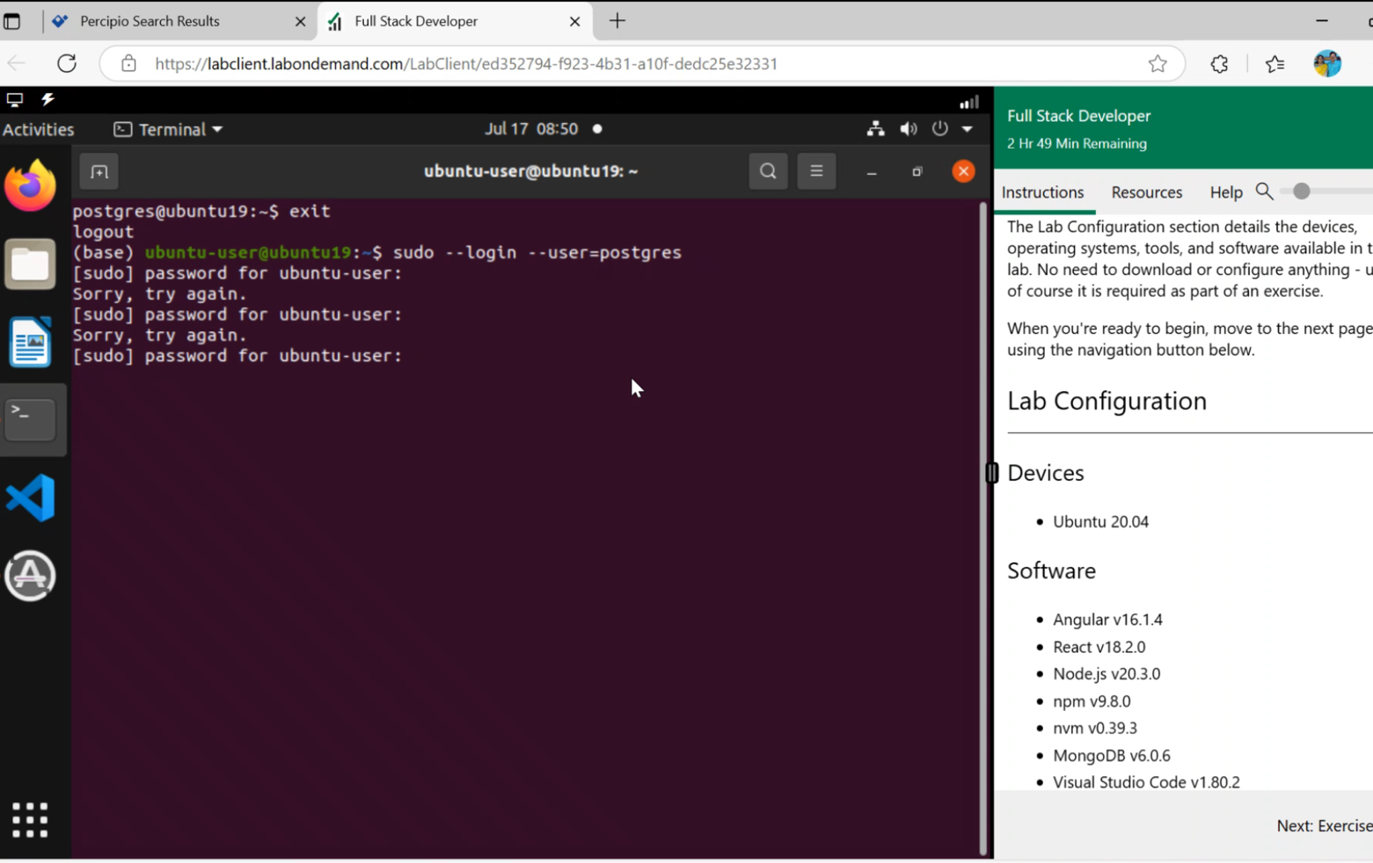
2. 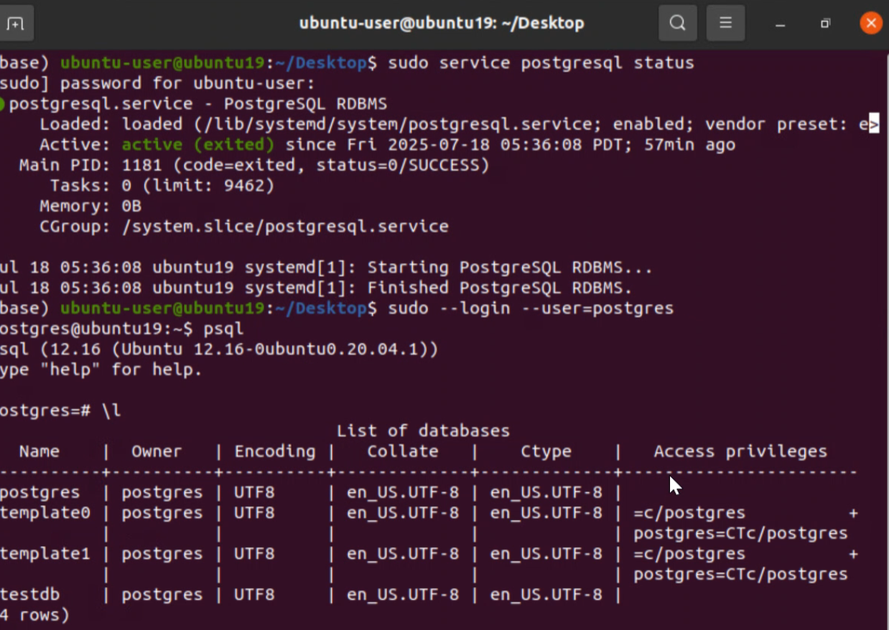

Kick Start

1. Start postgres
2. SHOW server_version;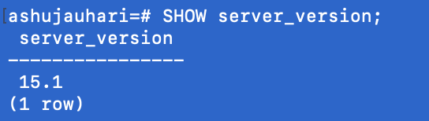
3. Connect to Database
   1. SELECT current_database();
   2. Ashujauhari # \c postgres



* 1. postgres=# \l

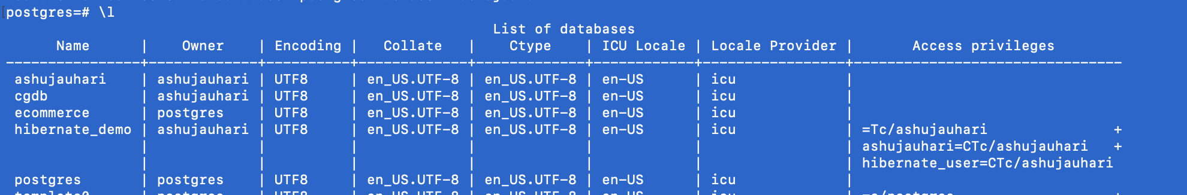

Create

\! clear

1. Create a Database

postgres=# CREATE DATABASE hr_system;

# Create Table

CREATE TABLE departments (

dept_id SERIAL PRIMARY KEY,

dept_name VARCHAR(50) NOT NULL

);

INSERT INTO departments (dept_name) VALUES

('Human Resources'),

('Finance'),

('Engineering'),

('Sales'),

('Marketing');

# Insert data to table

INSERT INTO departments (dept_name) VALUES

('Human Resources'),

('Finance'),

('Engineering'),

('Sales'),

('Marketing');

1. select * from departments;

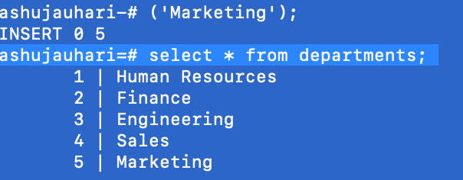

1. CREATE TABLE

CREATE TABLE employees (

emp_id SERIAL PRIMARY KEY,

emp_name VARCHAR(100) ,

gender CHAR(1) CHECK (gender IN ('M', 'F')),

hire_date DATE NOT NULL,

salary NUMERIC(10, 2) NOT NULL CHECK (salary > 0),

dept_id INT,

FOREIGN KEY (dept_id) REFERENCES departments(dept_id)

);

1. SELECT table_schema, table_name

FROM information_schema.tables

WHERE table_type = 'BASE TABLE'

AND table_schema NOT IN ('pg_catalog', 'information_schema');

INSERT

1. INSERT

Insert INTO employees (emp_name, gender, hire_date, salary, dept_id)

VALUES

('Alice Johnson', 'F', '2021-05-01', 75000, 1),

('Bob Smith', 'M', '2022-01-15', 90000, 2),

('Catherine Lee', 'F', '2020-09-10', 80000, 3),

('David Brown', 'M', '2019-03-20', 95000, 1),

('Eva Green', 'F', '2023-07-05', 72000, 4);

Select and Where

1. SELECT emp_name, salary FROM employees WHERE salary > 80000;
2. SELECT * FROM employees ORDER BY hire_date DESC LIMIT 3;

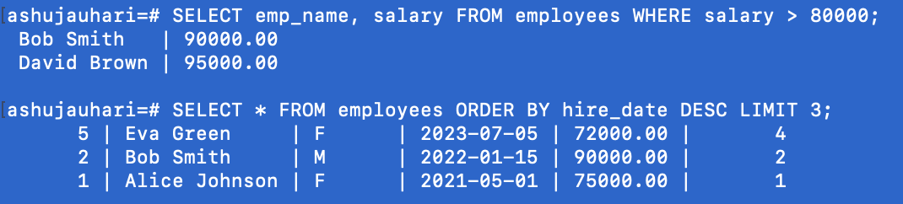

Update

1. UPDATE

Update employees SET salary = salary * 1.1 WHERE dept_id = 2;

Delete

1. DELETE

Delete FROM employees WHERE emp_name = 'Charlie Lee';

DELETE FROM employees

WHERE emp_name LIKE 'Charli%';

Functions

1. SELECT COUNT(*) AS total_employees FROM employees;
2. SELECT SUM(salary) AS total_payroll FROM employee;
3. SELECT AVG(salary) AS average_salary FROM employees;
4. SELECT emp_name, salary FROM employees WHERE salary > (SELECT AVG(salary) FROM employees);
5. SELECT e.emp_name, d.dept_name FROM employees e current_date

departments d ON e.dept_id = d.dept_id;

1. SELECT MIN(age) AS youngest_employee FROM employees;
2. SELECT MAX(salary) AS highest_salary FROM employees;

String Functions

1. SELECT LENGTH('PostgreSQL') AS len;
2. SELECT LOWER('PostgreSQL Rocks!') AS lower_str;
3. SELECT UPPER('PostgreSQL Rocks!') AS upper_str;
4. SELECT INITCAP('postgresql rocks!') AS initcap_str;
5. SELECT CONCAT('Hello', ' ', 'World') AS greeting;
6. SELECT SUBSTRING('PostgreSQL' FROM 1 FOR 4) AS sub_str;
7. SELECT TRIM(' Hello World ') AS trimmed_str;
8. SELECT REPLACE('PostgreSQL is awesome', 'awesome', 'powerful') AS replaced_str;

JOIN

1. --Inner Join--

SELECT e.emp_name, d.dept_name

FROM employees e

JOIN departments d ON e.dept_id = d.dept_id;

SELECT e.emp_name, d.dept_name

FROM employees e

LEFT JOIN departments d ON e.dept_id = d.dept_id;

SELECT

e.emp_name,

e.dept_id AS emp_dept_id,

d.dept_name,

d.dept_id AS dept_dept_id

FROM

employees e

FULL OUTER JOIN

departments d ON e.dept_id = d.dept_id;

Alter Table

1. ALTER T- ADD COLUMN

ALTER TABLE employees

ADD COLUMN manager_id INTEGER;

ALTER TABLE employees

ADD COLUMN mobile INTEGER;

1. ALTER TABLE employees RENAME COLUMN phone_number TO mobile;
2. ALTER TABLE employees DROP COLUMN mobile;
3. ALTER TABLE employees

ADD CONSTRAINT fk_manager

FOREIGN KEY (manager_id) REFERENCES employees(emp_id);

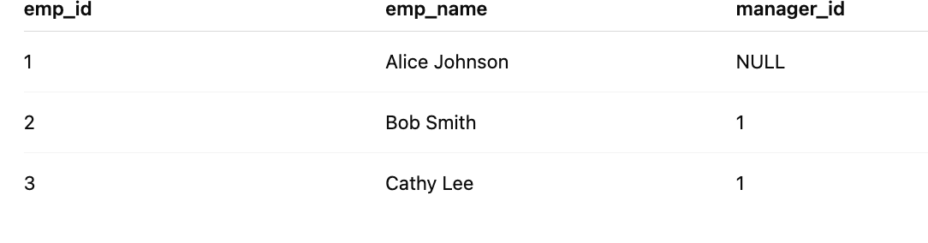

Group BY

1. Group BY

SELECT dept_id, COUNT(*) AS employee_count

FROM employees

GROUP BY dept_id;

1. SELECT gender, COUNT(*) AS gender_count

FROM employees

GROUP BY gender;

1. SELECT dept_id,

SUM(salary) AS total_salary,

AVG(salary) AS average_salary

FROM employees

GROUP BY dept_id;

SELECT

d.dept_name,

COUNT(e.emp_id) AS total_employees

FROM

employees e

INNER JOIN

departments d ON e.dept_id = d.dept_id

GROUP BY

d.dept_name;

26. Average salary per department

SELECT

d.dept_name,

AVG(e.salary) AS avg_salary

FROM

employees e

INNER JOIN

departments d ON e.dept_id = d.dept_id

GROUP BY

d.dept_name;

1. SELECT EXTRACT(YEAR FROM hire_date) AS hire_year,

COUNT(*) AS hires

FROM employees

GROUP BY hire_year

ORDER BY hire_year;

View

1. CREATE VIEW contact_info AS SELECT emp_id, emp_name FROM employees;
2. UPDATE contact_info SET emp_name = 'Me' WHERE emp_id = 2;
3. DROP VIEW IF EXISTS dept_salary_report;
4. CREATE VIEW contact_info AS
5. SELECT emp_id, emp_name FROM employees;
6. UPDATE contact_info SET emp_name = 'Me' WHERE emp_id = 2;
7. DROP VIEW IF EXISTS dept_salary_report;

Index

1. CREATE INDEX idx ON employees(dept_id);
2. CREATE INDEX idx_salary ON employees(salary);
3. \di

EXPLAIN ANALYZE

1. EXPLAIN ANALYZE

SELECT e.emp_name, e.salary, d.dept_name

FROM employees e

JOIN departments d ON e.dept_id = d.dept_id

WHERE e.salary > (

SELECT AVG(salary) FROM employees WHERE dept_id = e.dept_id

);

1. EXPLAIN ANALYZE

SELECT d.dept_name, COUNT(e.emp_id)

FROM departments d

LEFT JOIN employees e ON d.dept_id = e.dept_id

GROUP BY d.dept_name;

Function

1. SELECT emp_name, LENGTH(emp_name) AS name_length FROM employees;
2. SELECT emp_name, LOWER(email) AS lowercase_email FROM employees;
3. SELECT emp_name, UPPER(emp_name) AS name_caps FROM employees;
4. SELECT emp_name, INITCAP(LOWER(emp_name)) AS proper_case FROM employees;
5. SELECT emp_name, CONCAT(emp_name, ' <', gender, '>') AS contact_display FROM employees;
6. SELECT emp_name, SUBSTRING(emp_name FROM 1 FOR 5) AS partial_name FROM employees;
7. SELECT emp_name, REPLACE(email, '@company.com', '@corp.com') AS updated_email FROM employees;
8. SELECT emp_id, REPLACE(emp_name, 'Eva', 'Jonathan') AS updated_name correlated FROM employees;

Date Function

1. SELECT CURRENT_DATE AS today;
2. SELECT CURRENT_TIMESTAMP AS current_date_time;
3. SELECT EXTRACT(YEAR FROM CURRENT_DATE) AS year,

EXTRACT(MONTH FROM CURRENT_DATE) AS month,

EXTRACT(DAY FROM CURRENT_DATE) AS day;

1. SELECT NOW() AS current_timestamp;
2. SELECT

DATE_TRUNC('month', CURRENT_TIMESTAMP) AS month_start,

DATE_TRUNC('day', CURRENT_TIMESTAMP) AS day_start;

// • month_start: the timestamp set to the **first day of the current month at 00:00:00**.

• day_start: the timestamp set to the **start of the current day at 00:00:00**.

1. SELECT TO_CHAR(CURRENT_DATE, 'DD-Mon-YYYY') AS formatted_date;
2. SELECT AGE(DATE '2025-07-17', DATE '2000-01-01') AS age_between_dates;

JSONb

1. CREATE TABLE Products (

product_id SERIAL PRIMARY KEY,

name VARCHAR(100),

attributes JSONB

);

1. INSERT INTO products (name, attributes) VALUES

('Laptop', '{

"brand": "Dell",

"specs": { "ram": "16GB", "storage": "512GB" },

"price": 799.99

}'::jsonb),

('Smartphone', '{

"brand": "Samsung",

"specs": { "ram": "8GB", "storage": "128GB" },

"price": 599.49

}'::jsonb),

('Tablet', '{

"brand": "Apple",

"specs": { "ram": "4GB", "storage": "64GB" },

"price": 429.99

}'::jsonb);

**Get brand: -> retrieves JSON value**

1. SELECT name, attributes -> 'brand' AS brand FROM products;

#### **Get RAM size using -> and ->>: ->> retrieves text value.**

1. SELECT name,attributes -> 'specs' ->> 'ram' AS ram_size FROM products;

**Use #> for nested keys (as array):**

1. SELECT name, attributes #> '{specs,storage}' AS storage_size

FROM products;

**Use jsonb_each() to expand key-value pairs**

1. SELECT name, key, value

FROM products, jsonb_each(attributes);

**Use jsonb_array_elements() (if value is an array)**

1. UPDATE products

SET attributes = jsonb_set(attributes, '{features}', '["Touchscreen", "Backlit Keyboard"]');

**Filter Records Using JSONB**

1. SELECT *

FROM products

WHERE (attributes ->> 'price')::numeric > 500;

1. SELECT *

FROM products

WHERE attributes ? 'brand';

Scalar Subqueries

Returns **a single value (one row, one column)**.

**Example: Get all employees whose salary is above the average salary**

1. SELECT emp_id, emp_name, salary

FROM employees

WHERE salary > (SELECT AVG(salary) FROM employees);

**Employees earning above average**

1. SELECT emp_id, emp_name, salary

FROM employees

WHERE salary > (SELECT AVG(salary) FROM employees);

**Find Employees with Salary = MAX Salary**

1. SELECT emp_id, emp_name, salary

FROM employees

WHERE salary = (SELECT MAX(salary) FROM employees);

**Employees from the Largest Department**

1. Select emp_id, emp_name

FROM employees

WHERE dept_id = (

SELECT dept_id

FROM employees

GROUP BY dept_id

ORDER BY COUNT(*) DESC

LIMIT 1 );

**Department Located in Specific City**

1. SELECT *

FROM departments

WHERE location = (

SELECT location

FROM departments

WHERE dept_name = 'Sales');

**Difference Between Max and Min Salary**

1. SELECT (

(SELECT MAX(salary) FROM employees) -

(SELECT MIN(salary) FROM employees)

) AS salary_gap;

**Show Total Salary of Employees in Smallest Department**

1. SELECT SUM(salary)

FROM employees

WHERE department_id = (

SELECT department_id

FROM employees

GROUP BY department_id

ORDER BY COUNT(*) ASC

LIMIT 1

);

**Hire Date of the Most Recent Joiner**

1. SELECT name, hire_date

FROM employees

WHERE hire_date = (

SELECT MAX(hire_date) FROM employees);

Correlated Subqueries

## Employees with salary greater than department average

// **Check average salaries per department**:

SELECT e.emp_name, e.salary, e.dept_id,

(SELECT AVG(e2.salary)

FROM employees e2

WHERE e2.dept_id = e.dept_id) AS dept_avg

FROM employees e;

INSERT INTO employees (emp_name, gender, hire_date, salary, dept_id) VALUES

('Tom Hill', 'M', '2021-02-10', 70000, 1),

('Amy Wong', 'F', '2021-05-12', 67000, 1),

('Raj Patel', 'M', '2022-11-03', 105000, 2),

('Linda Roe', 'F', '2020-04-22', 78000, 3);

SELECT e.emp_name, e.salary, e.dept_id

FROM employees e

WHERE e.salary > (

SELECT AVG(e2.salary)

FROM employees e2

WHERE e2.dept_id = e.dept_id

);

SELECT e.emp_name, e.salary, e.dept_id

FROM employees e

WHERE EXISTS (

SELECT 1

FROM employees e2

WHERE e2.dept_id = e.dept_id

GROUP BY e2.dept_id

HAVING e.salary > AVG(e2.salary)

);

## Customers who placed orders worth more than their average order value

SELECT c.customer_id, c.name

FROM customers c

WHERE EXISTS (

SELECT 1

FROM orders o

WHERE o.customer_id = c.customer_id

AND o.total > (

SELECT AVG(o2.total)

FROM orders o2

WHERE o2.customer_id = c.customer_id

));

## Find employees who earn more than their manager

SELECT e.emp_name, e.salary

FROM employees e

WHERE e.salary > (

SELECT m.salary

FROM employees m

WHERE m.emp_id = e.manager_id

);

**Windows Functions**

**RANK employees by salary** in each department

SELECT emp_name, dept_id, salary,

RANK() OVER (PARTITION BY dept_id ORDER BY salary DESC) AS rank_in_dept

FROM employees;

**Calculate average salary** in each department along with individual salary

SELECT emp_name, dept_id, salary,

AVG(salary) OVER (PARTITION BY dept_id) AS avg_salary_dept

FROM employees;

**Row number** of each employee based on hire date

SELECT emp_name, hire_date,

ROW_NUMBER() OVER (ORDER BY hire_date ASC) AS row_num_by_hire_date

FROM employees;

**Cumulative salary** (running total) by department

SELECT emp_name, dept_id, salary,

SUM(salary) OVER (PARTITION BY dept_id ORDER BY emp_name) AS running_total_salary

FROM employees;

### **Previous employee salary** in the same department (using LAG)

SELECT emp_name, dept_id, salary,

LAG(salary, 1) OVER (PARTITION BY dept_id ORDER BY salary) AS previous_salary

FROM employees;

**Next employee salary** in the same department (using LEAD)

SELECT emp_name, dept_id, salary,

LEAD(salary, 1) OVER (PARTITION BY dept_id ORDER BY salary) AS next_salary

FROM employees;

**Find % difference from department average salary**

SELECT emp_name, dept_id, salary,

ROUND((salary - AVG(salary) OVER (PARTITION BY dept_id)) /

AVG(salary) OVER (PARTITION BY dept_id) * 100, 2) AS percent_diff_from_avg

FROM employees;

Common Table Expressions (CTEs)

**Get employees with above-average salary using CTE**

WITH avg_salary_cte AS (

SELECT AVG(salary) AS avg_sal

FROM employees

)

SELECT emp_name, salary

FROM employees, avg_salary_cte

WHERE employees.salary > avg_salary_cte.avg_sal;

**Security and Access Control**

CREATE ROLE analyst LOGIN PASSWORD 'securepass';

GRANT CONNECT ON DATABASE companydb TO analyst;

Privileges and GRANT/REVOKE

GRANT SELECT ON employees TO analyst;

REVOKE UPDATE ON employees FROM analyst;

Row-Level Security (RLS)

Enable RLS

ALTER TABLE employees ENABLE ROW LEVEL SECURITY;

-- Create a policy

CREATE POLICY emp_policy

ON employees

FOR SELECT USING (emp_id = current_user::int);

SELECT to_tsvector('english', 'The quick brown fox jumps over the lazy dog.');

## Step-by-Step: Add tsvector and Full-Text Search

* + 1. Add a search_vector column:
       - ALTER TABLE employees ADD COLUMN search_vector tsvector;
    2. Populate search_vector with searchable fields:

UPDATE employees

SET search_vector = to_tsvector(

'english',

emp_name || ' ' || gender || ' ' || salary::TEXT

);

* + 1. Create a GIN index for fast searching:

CREATE INDEX idx_gin_employee_search

ON employees USING **GIN**(search_vector);

* + 1. Example full-text query:

-- Search for employees with name or gender containing "M" and "50000"

SELECT emp_id, emp_name, gender, salary

FROM employees

WHERE search_vector @@ to_tsquery('M & 50000');

Advanced index types (GIN, GiST, BRIN)

# GIST

CREATE TABLE bookings (

id SERIAL,

room_id INT,

availability DATERANGE

);

INSERT INTO bookings (room_id, availability)

VALUES (101, '[2025-08-01, 2025-08-10)');

CREATE INDEX idx_gist1_availability

ON bookings USING GIST(availability);

CREATE TABLE meetings (

id SERIAL PRIMARY KEY,

room_id INT,

meeting_time TSRANGE

);

INSERT INTO meetings (room_id, meeting_time)

VALUES (1, '[2025-07-19 10:00, 2025-07-19 11:30)');

INSERT INTO meetings (room_id, meeting_time)

VALUES (1, tsrange('2025-07-19 14:00', '2025-07-19 15:00', '[)'));

# BRIN

**Step 1: Table with timestamped sensor data:**

CREATE TABLE sensor_data1 (

id SERIAL PRIMARY KEY,

sensor_id INT,

reading NUMERIC,

reading_time TIMESTAMP

);

Step 2: Create BRIN index.

CREATE INDEX idx_brin_senso1r_time

ON sensor_data USING BRIN(reading_time);

INSERT INTO sensor_data1 (sensor_id, reading, reading_time) VALUES

(101, 23.7, '2025-07-19 08:30:00'),

(102, 18.5, '2025-07-19 08:31:15'),

(101, 24.1, '2025-07-19 08:32:45'),

(103, 22.9, '2025-07-19 08:34:00'),

(102, 19.3, '2025-07-19 08:35:30');

Step 3: Query that benefits from BRIN:

SELECT * FROM sensor_data

WHERE reading_time BETWEEN '2025-07-10' AND '2025-07-19';

Basic Backup Command

pg_dump -U postgres -d mydb > mydb_backup.sql

-U User name

-d Database name

> Redirect output to file

Backup with Custom Format (Compressed)

pg_dump -U postgres -F c -f mydb_backup.dump mydb

| **Flag** | **Description** |
| --- | --- |
| -F c | Format = custom (compressed) |
| -f | Output file name |

Restore

3. Restoring from SQL File

psql -U postgres -d newdb < mydb_backup.sql

4. Restoring from Custom Dump

pg_restore -U postgres -d newdb mydb_backup.dump

You can also **list contents**:

pg_restore -l mydb_backup.dump

PITR

Step 1. Take a Physical Base Backup

pg_basebackup -U postgres -D /var/lib/postgresql/backup/ -Ft -z -P

| **Flag** | **Description** |
| --- | --- |
| -D | Directory to store backup |
| -Ft | Format = tar |
| -z | Compress |
| -P | Show progress |

Step 2. Enable WAL Archiving (in postgresql.conf)

wal_level = replica

archive_mode = on

archive_command = 'cp %p /var/lib/postgresql/wal_archive/%f'

Step 3: Restore and Recover to Point-in-Time

* 1. Stop PostgreSQL

sudo systemctl stop postgresql

* 1. Replace Data Directory with Backup

rm -rf /var/lib/postgresql/14/main/*

tar -xvf base.tar -C /var/lib/postgresql/14/main/

* 1. Create recovery.signal and postgresql.auto.conf

touch /var/lib/postgresql/14/main/recovery.signal

echo "restore_command = 'cp /var/lib/postgresql/wal_archive/%f %p'" >> postgresql.auto.conf

echo "recovery_target_time = '2025-07-18 10:45:00'" >> postgresql.auto.conf

* 1. Start PostgreSQL

sudo systemctl start postgresql

Trigger

CREATE TABLE departments (

dept_id SERIAL PRIMARY KEY,

dept_name VARCHAR(100) NOT NULL

);

CREATE TABLE employees (

emp_id SERIAL PRIMARY KEY,

emp_name VARCHAR(100) NOT NULL,

gender CHAR(1),

hire_date DATE NOT NULL,

salary NUMERIC(10,2) NOT NULL,

dept_id INTEGER REFERENCES departments(dept_id),

manager_id INTEGER

);

## Create audit_log table for trigger logging

CREATE TABLE audit_log (

log_id SERIAL PRIMARY KEY,

action_time TIMESTAMP DEFAULT CURRENT_TIMESTAMP,

action TEXT

);

## Write the Trigger Function

CREATE OR REPLACE FUNCTION log_new_employee()

RETURNS TRIGGER AS $$

BEGIN

INSERT INTO audit_log(action)

VALUES (

'New employee added: ' || NEW.emp_name ||

', Department ID: ' || NEW.dept_id

);

RETURN NEW;

END;

$$ LANGUAGE plpgsql;

**Create the Trigger**

CREATE TRIGGER after_employee_insert

AFTER INSERT ON employees

FOR EACH ROW

EXECUTE FUNCTION log_new_employee();

Test It!

INSERT INTO departments (dept_name) VALUES ('IT');

INSERT INTO employees (emp_name, gender, hire_date, salary, dept_id, manager_id)

VALUES ('Alice Smith', 'F', '2024-05-10', 75000, 1, NULL);

SELECT * FROM audit_log;

## Transaction

CREATE TABLE staff (

emp_id SERIAL PRIMARY KEY,

emp_name VARCHAR(50),

salary NUMERIC

);

INSERT INTO staff (emp_name, salary)

VALUES ('Alice', 50000),('Bob', 60000),('Charlie', 70000);

## COMMIT

-- Start a transaction

BEGIN;

-- Update Bob’s salary

UPDATE staff SET salary = 65000 WHERE emp_name = 'Bob';

-- Check the updated data before committing

SELECT * FROM staff;

-- Make the change permanent

COMMIT;

## ROLLBACK

-- Start another transaction

BEGIN;

-- Try updating Alice’s salary

UPDATE staff SET salary = 100000 WHERE emp_name = 'Alice';

-- Oops! Realized it was a mistake

ROLLBACK;

SELECT * FROM staff;

## Savepoint

BEGIN;

-- Do something

SAVEPOINT savepoint_name;

-- Do more

-- Roll back only to savepoint if needed

ROLLBACK TO SAVEPOINT savepoint_name;

-- Finalize transaction

COMMIT;

## Example -Savepoint

-- Start the transaction

BEGIN;

-- Step 1: Give Charlie a raise

UPDATE staff SET salary = salary + 10000 WHERE emp_name = 'Charlie';

-- Set savepoint here

SAVEPOINT after_charlie_raise;

-- Step 2: Try to give Bob a huge raise (assume this is a mistake)

UPDATE staff SET salary = salary + 500000 WHERE emp_name = 'Bob';

-- Realize the mistake and rollback to savepoint

ROLLBACK TO SAVEPOINT after_charlie_raise;

-- Now Bob's raise is undone, but Charlie's raise is still there

-- Commit changes so far

COMMIT;